Diabetic Retinopathy Screening (Based on CNN)
One of the biomedical fields, where digital image processing and artificial intelligence are applied is diagnostics in ophthalmology. It deals with digital images of the human retina. Early detection of the anomalies on the retina images is of great importance for the diagnosis of various types of diseases that people can suffer from.
Diabetic retinopathy (DR) is one of the most important causes of visual loss worldwide and is the principal cause of impaired vision in patients between 25 and 74 years of age. Visual loss from DR may be secondary to macular oedema (ME; retinal thickening and oedema involving the macula), haemorrhage from new vessels, retinal detachment, or neovascular glaucoma. The vast majority of patients with developing DR have no symptoms until the very late stages. Because the rate of progression may be rapid, and therapy can be beneficial for both symptom amelioration and reduction in the rate of disease progression, it is important to screen patients with diabetes regularly for the development suppression of the retinal disease.

Screening of Diabetic Retinopathy (DR) - State-of-the-art
Diagnostics
The most usual examination of diabetes patients consists in direct diagnosis by an ophthalmologist in an ambulance with a fundus camera without any image record. It is time and resources consuming and does not enable continual monitoring of disease development.
On the other hand, automatic screening using digital image processing and artificial intelligence methods enables automatic evaluation of images, monitoring of detected founding and considerable reduction of resources.
There are no universally accepted criteria for the detection of DR using digital imaging. British Diabetic Association recommends minimum 80% sensitivity and 95% specificity for screening methods*.

(*British Diabetic Association. Retinal photographic screening for diabetic eye disease. A British Diabetic Association Report. London: British Diabetic Association; 1997)

DIP methods used
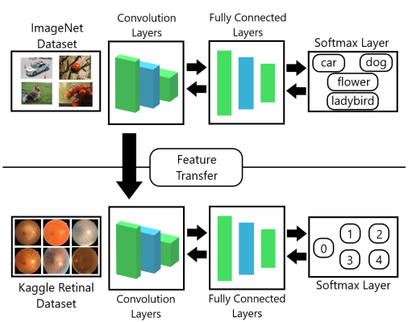

Fig. 1 Training of CNN using transfer learning
We use the following methods:
• classification methods - presence/absence of DR, resp. grading of DR to 4 classes
• morphological methods,
• clustering algorithms, SVM (Support Vector Machines), CBIR (Content Based Image Retrieval),
• deep learning – classification: CNN, LBCNN, RFNN, reinforcement learning, U-net – convolutional autoencoders
• evaluation - lesion based, pixel based, image based, whole image, image blocks (128x128)
• detection and segmentation of vessels, optic disc, macula, and DR artefacts (exudates, hemorrhages, …) by R-CNN, faster R-CNN, JOLO, SSD and U-net detectors
…………………………………………………………………………………………………………………………………………………..
We use public databases Messidor, Eoptha Ex, Kaggle, DRIVE, IOSTAR, and ODIR ...
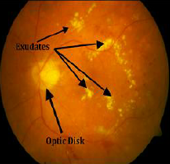
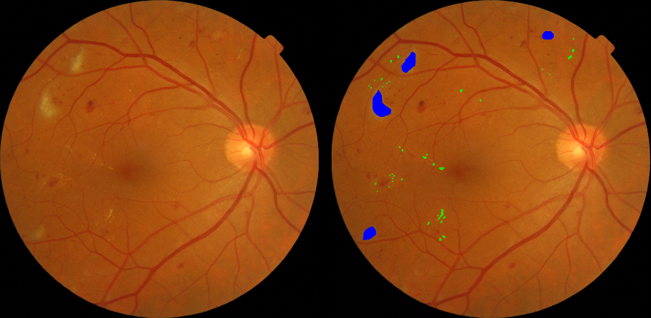

Fig. 2 left: Symptoms od DR; right: fundus image pair: original and ground truth image marked by our ophthalmologist
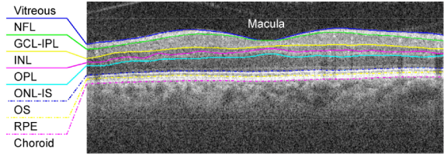
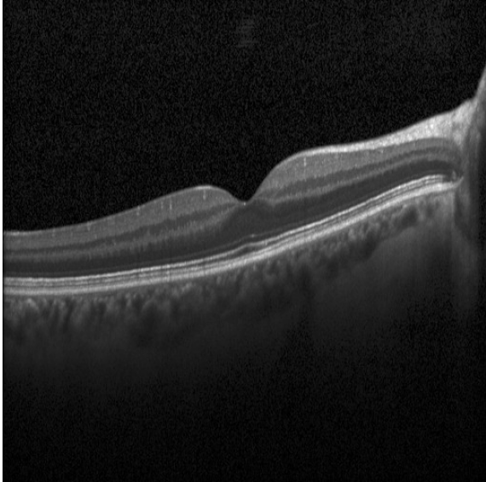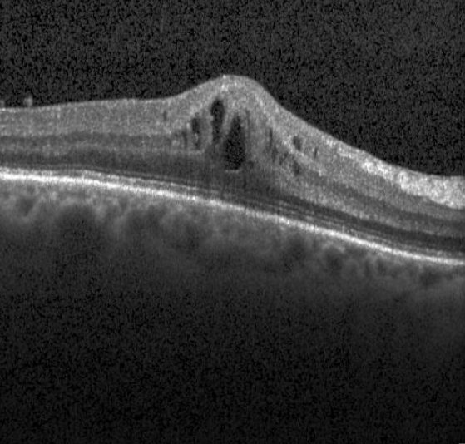
Fig.3 OCT image –left: healty macula, middle: retina with macular edema, right: segments of mcula

29 colour fundus images of subjects with diabetic retinopathy from Messidor database are precisely marked by our ophthalmologist. At all 29 images, hard and soft exudates are marked (pixel based).
We finalize marking/labelling of optic disc and macula on fundus images for precise segmentation evaluation (500 images)

Pre-processing and image transforms
We work with colour and grey level images, with green channel of a colour images and with images in different feature spaces (contrast and illumination variations, adaptive histogram equalization, illumination transform, LBP (Local Binary Pattern) feature space, ai.).

We can localize optic disc (OD) macula, and vessels on fundus images with 92% and 95 % accuracy respectively, using DIP methods (FRST, Hough transform, mathematical morphology, colour histogram) [10,12] and newly by CNN detectors (R-CNN, YOLO, SSD and U-net) [3,4].
DR classification
Our results of DR classification (presence/absence of DR, resp. grading of DR to 4 classes) can be found in [2], where we present trainable features reduction by modified LBCNN network, in [8,9,14,15], where different architectures of CNN were used, in [5] we applied pretrained deep NN for classification DR to 4 classes on Kaggle dataset. The best results of the average classification accuracy were achieved by Inception v3 network with the average success rate of 70.29%
Hard exudates detection and segmentation
We developed the algorithm for hard exudates detection and segmentation on retinal fundus images based on combination of faster R-CNN detector and SM classifier on the pixel level and on image level. We achieved reduction of false positive findings and speeded up the segmentation process [1].
Bright lesions classification evaluation
There is a big difference between accuracy values in literature depending on the evaluation method.
We develop own evaluation method based on block classification of bright lesions on exactly (pixel-based| marked fundus images [6].

Summary of our publications
- Kurilová, V., Goga, J., Oravec, M.,Pavlovičová, J., Kajan, S. (2021): Support vector machine and deep-learning object detection for localisation of hard exudates, Nature Scientific Reports 11, 16045 (2021), Q1, IF 4.379

- Macsik, P., PAVLOVIČOVÁ, J., GOGA, J., KAJAN, S. (2021) Local binary CNN for diabetic retinopathy classification on fundus images, Acta Polytechnica Hungarica (accepted)
- KAJAN, S., PAVLOVIČOVÁ, J., GOGA, J., KURILOVÁ, V., KRAJNAK, R, LACKO, K., (2021) Detection of optic disc and macula in retinal images using deep learning methods, IWSSIP 2021, Bratislava
- PIRHALA, M., GOGA, J., KURILOVÁ, V., PAVLOVIČOVÁ, J. (2021) Segmentation of signiﬁcant areas in retinal images, IWSSIP 2021, Bratislava
- KAJAN, S., GOGA, J., LACKO, K., PAVLOVIČOVÁ, J.,(2020) Detection of Diabetic Retinopathy Using Pretrained Deep Neural Networks, K&I'20, Int. Conference Cybernetics & Informatics 2020, Velké Karlovice, Czech Republic, January 29 - February 1, 2020
- PAVLOVIČOVÁ, J. - KAJAN S.- Marko, M.- ORAVEC, M. - KURILOVÁ, V. (2018) Bright Lesions Detection on Retinal Images by Convolutional Neural Network. In Proceedings ELMAR-2018: 60th International symposium. Zadar, Croatia.
- LODERER, M., PAVLOVIČOVÁ J., ORAVEC M. (2018): Comparative Study of Local Binary Pattern Derivatives for Low Size Feature Vector Representation in Face Recognition, Acta Polytechnica Hungarica, Vol. 15, No. 4, 2018, pp. 199-216
- ANDONOVA. M. - PAVLOVIČOVÁ, J. -KAJAN S.- ORAVEC, M. - KURILOVÁ, V. (2017) Diabetic Retinopathy Screening Based on CNN. In Proceedings ELMAR-2017: 59th International symposium. Zadar, Croatia. 11-13 September 2017. Zagreb: University of Zagreb, 2017, pp. 51-54. ISSN 1334-2630. ISBN 978-953-184-230-3.AFC / WoS /
- KAJAN, M., ORAVEC, M., PAVLOVIČOVÁ, J., KURILOVÁ, V. (2016) Determination of bright lesions in fundus images. In Proceedings ELMAR-2016: 58th International symposium. Zadar, Croatia. 12-14 September 2016. Zagreb: University of Zagreb, 2016, pp. 77-80. ISSN 1334-2630. ISBN 978-953-184-221-1.AFC / WoS /
- LESAY, Boris - PAVLOVIČOVÁ, Jarmila - ORAVEC, Miloš - KURILOVÁ, Veronika. (2016) Optic disc localization in fundus image. In IWSSIP 2016: 23th International conference on systems, signals and image processing. Bratislava, Slovakia. 23-25 May 2016. 1. vyd. Bratislava: Slovak University of Technology in Bratislava, 2016, pp. 125-128. ISBN 978-1-4673-9555-7. IEEE. AFD/ Scopus /
- KOMORNÝ, Jakub - KURILOVÁ, Veronika - PAVLOVIČOVÁ, Jarmila. (2016) Image enhancement for diagnostics in ophthalmology. In Redžúr 2016 [electronic source]: 10th International workshop on multimedia and signal processing. Bratislava, Slovakia. May 24, 2016. 1. ed. Bratislava: Nakladateľstvo STU, 2016, CD-ROM, S. 19-22. ISBN 978-80-227-4560-4.
- Kurilová, V., Pavlovičová, J., Oravec, M., Rakár, R., Marček, I. (2015) Retinal Blood Vessels Extraction Using Morphological Operations, In 22nd International Conference on Systems, Signals and Image Processing IWSSIP 2015. 10-12 September, London, UK, pp. 265-268, ISBN 978-1-4673-8352-3 / WoS /
- Loderer, M., Pavlovičová, J. (2014): Optimization of LBP Parameters, 56th International Symposium ELMAR-2014, 10-12 September 2014, Zadar, Croatia, pp. 111-114, ISBN 978-953-184-199-3 / WoS/
- HANÚSKOVÁ, V., PAVLOVIČOVÁ, J., ORAVEC, M., BLAŠKO, R. (2013) Diabetic Retinopathy Screening by Bright Lesions Extraction from Fundus Images, Journal of Electrical Engineering, ISSN 1335-3632, Vol. 64, No.5, 2013, pp. 311-316, http://iris.elf.stuba.sk/JEEEC/data/pdf/5_113-7.pdf, / WoS /
- Bédi, J., Nagy, T., Oravec, M., Pavlovičová, J. (2012): Machine Learning Methods for Ophthalmology Diagnostics. In: Student Scientific Conf. ŠVOČ 2012: Proc. of selected papers, Bratislava, 25. April 2012. - Bratislava: FEI STU, 2012., ISBN 978-80-227-3697-8. - S. 16-20

Projects
MLbiomedia - Advanced Machine Learning Methods for Proposal of Biometrics and Medical Diagnostic Systems, VEGA 1/0867/17, 2017-20
Advanced Image Processing Algorithms for Effective Human Face Retrieval and Coding, VEGA 1/0961/11

